Kronos Kontrol
User guide — Max for Live device for the Korg KRONOS (OS 3.2.3)
Le grand livre du KRONOS — included product: Ableton Live · François Rossi · October 2026

1. Overview
Kronos Kontrol is a Max for Live device (MIDI Effect) that controls a Korg KRONOS from an Ableton Live MIDI track. Its interface is a 19" rack front panel: 16 sound encoders, mode, bank and program selection, effect switches, an X-Y pad, an 8-encoder mixer and the KARMA section.
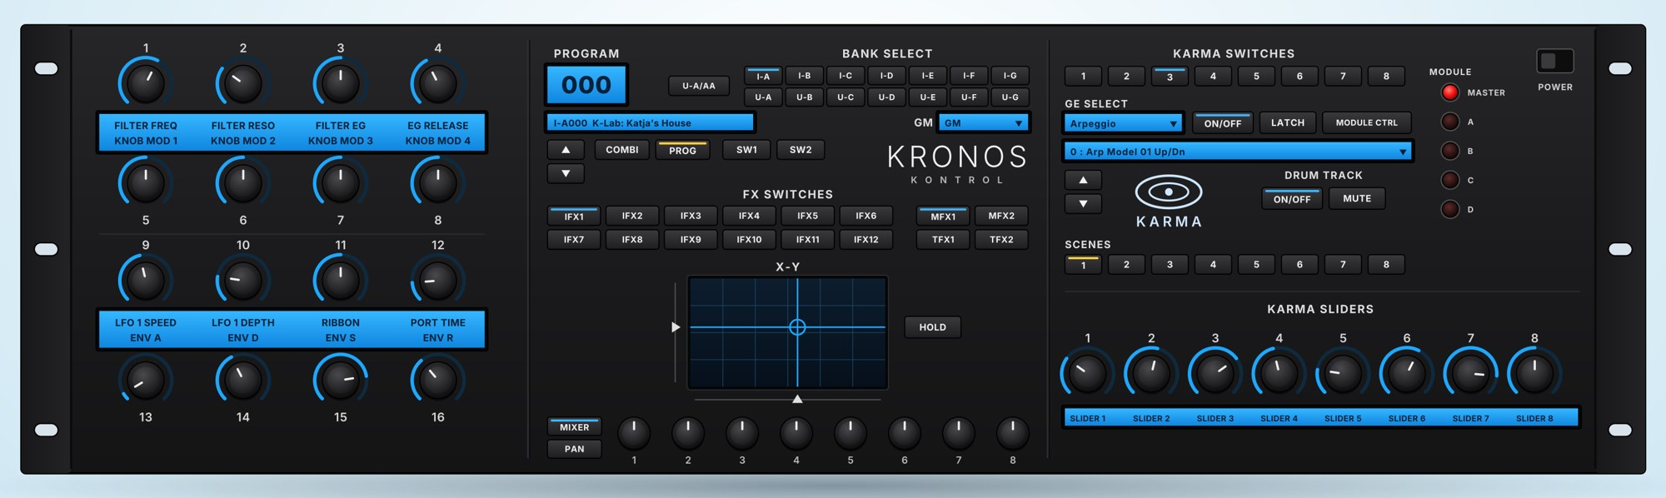
Three identical files are supplied; only the button text in Live's device strip changes:
- Kronos Kontrol OS3.2.3_FR.amxd — OUVRIR LE RACK
- Kronos Kontrol OS3.2.3_EN.amxd — OPEN RACK
- Kronos Kontrol OS3.2.3_ES.amxd — ABRIR EL RACK

2. Requirements
- A Korg KRONOS (KRONOS, KRONOS 2 or KRONOS 3) running OS 3.2.x, connected to the computer by USB.
- Ableton Live 11.1 or later with Max for Live (Live 12 Suite recommended). No external .maxpat patch is needed.
- Live's audio engine must be running (an audio device selected in Preferences › Audio); otherwise the device sends nothing.

3. Installation
- Copy the .amxd file for your language to your User Library: …\User Library\Presets\MIDI Effects\Max MIDI Effect\.
- In Live: Preferences › Tempo & MIDI › Output Ports: enable "Track" for the KRONOS (KRONOS 1 SOUND on Windows).
- Create a MIDI track and set "MIDI To" to the KRONOS, channel 1.
- Drag the device onto the track. The strip shows KRONOS / KONTROL, the sound name and the OPEN RACK button.

4. KRONOS settings
- GLOBAL › P0 Basic Setup › Bank Map: KORG.
- GLOBAL › P1 MIDI: global MIDI channel 1 and Enable Exclusive checked (the device sends SysEx).
- For KARMA: the KARMA CCs are off by default. GLOBAL › page menu › Reset Controller MIDI Assign › To: CC Default, then Write Global Setting.
The sound names shown are those of the factory OS 3.2 PRELOAD. If you have loaded another PCG, the displayed name may differ from the sound being played.

5. The device strip and the rack window
Live's device chain has a fixed height (169 pixels): the strip only shows the title, the sound name and the OPEN RACK button. Click it to open the full rack in a 1500 × 414 pixel window. Close it whenever you like: the settings are saved with the Live set.

6. Left section: 16 sound encoders
Two groups of 8 encoders; their names appear in the blue strips. Each encoder sends a CC on the track's channel.
No. | Function | CC
1 | Filter Freq | CC74
2 | Filter Reso | CC71
3 | Filter EG | CC79
4 | EG Release | CC72
5–8 | Knob Mod 1–4 | CC17, 19, 20, 21
9 | LFO 1 Speed | CC76
10 | LFO 1 Depth | CC77
11 | Ribbon | CC16
12 | Port Time | CC5
13–16 | ENV A, D, S, R | CC73, 75, 70, 72

7. Centre section

Program and modes
- PROGRAM display: sound number and name. ▲ ▼: next / previous sound.
- COMBI / PROG: selects the KRONOS mode (the button lit in yellow is the active mode).
- SW1 / SW2: the two assignable KRONOS switches.

BANK SELECT
- I-A … I-G (top row) and U-A … U-G (bottom row): bank selection, as on the KRONOS.
- U-A/AA: when lit, buttons U-A … U-G select banks U-AA … U-GG (Program mode).
- GM: in Program mode, the 7th bank can be GM or its variations g(1) … g(9), g(d).

FX SWITCHES
IFX1 to IFX12 (two rows), MFX1–MFX2 and TFX1–TFX2: switch the insert, master and total effects of the current sound (Program or Combi) on or off.

X-Y
The X-Y pad sends CC118 (X) and CC119 (Y), like the vector joystick. HOLD keeps the position.

MIXER / PAN: the 8 lower encoders
MIXER and PAN are mutually exclusive: the lit button selects what the 8 encoders control.
 | MIXER (volume) | PAN
Combi | Volume of timbres 1 to 8 | Pan of timbres 1 to 8
Program | 1 OSC1, 2 OSC2, 3 Drum Track, 8 Master Volume | 1 OSC1, 2 OSC2

8. Right section: KARMA and Drum Track
- KARMA SWITCHES 1–8, GE SELECT (category) and GE menu (the KRONOS's 3,584 GEs), ON/OFF, LATCH, MODULE CTRL, ▲ ▼.
- MODULE indicators: MASTER, A, B, C, D (controlled module).
- SCENES 1–8 and KARMA SLIDERS 1–8 (CC22 to CC29).
- DRUM TRACK: ON/OFF starts the drum track; MUTE silences it (Program mode).

9. Troubleshooting
- Nothing happens: check that Live's audio engine is running, that "MIDI To" targets the KRONOS and that the "Track" output is enabled.
- Modes, FX or GE do not change: check Enable Exclusive and global channel 1 on the KRONOS.
- KARMA does not respond: perform Reset Controller MIDI Assign (section 4).
- Wrong bank: check that the KRONOS Bank Map is set to KORG.

10. Test status
Tested in Live 12 with a KRONOS (OS 3.2.3, 16 October 2026): Program and Combi modes, banks and programs, IFX switches, MIXER and PAN in Combi, MIXER in Program, Drum Track MUTE. KARMA, GE selection and the X-Y pad have not yet been checked with this version.
The device never writes (Write/Store) to the KRONOS: it only changes the edit buffer. To keep your settings in the KRONOS, save the sound on the KRONOS itself.

